Why is HD lace so expensive?

Expensive is relative, HD lace is expensive than regular swiss lace.

The characteristics of HD lace: Suitable for all skin tones
High definition
high transparency
thinnest lace
melt with all skin tone perfectly
The characteristics of Swiss lace : Four different lace colors with different skin tones
transparent Swiss lace ,
light brown Swiss lace ,
medium brown Swiss lace ,
dark brown Swiss lace
It is more intuitive to illustrate the difference with a picture
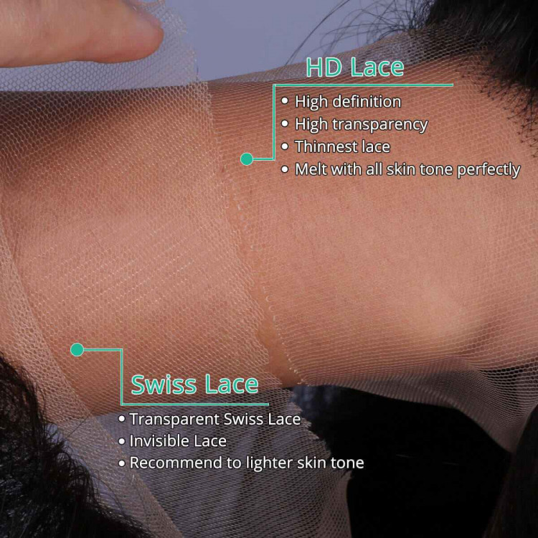
HD lace with pre plucked hairline on 360 lace wigs ,That is why 360 lace wigs so popular now.


